PHASE – 2
Feasibility Study & Requirement Analysis
- Purpose
The Feasibility Study and Requirement Analysis phase is carried out to evaluate whether the proposed OpenStack private cloud can be successfully implemented using the available infrastructure, software, and organizational resources. This phase validates the requirements gathered in Phase 1 and identifies the most suitable architecture, deployment methodology, and technology stack for a production-grade environment.
The outcome of this phase provides confidence that the proposed solution is technically feasible, scalable, secure, and capable of meeting future business requirements.

Objectives
The primary objectives of this phase are:
  - Analyze the requirements collected during the Requirement Gathering phase.
  - Evaluate the feasibility of deploying a production-grade OpenStack environment.
  - Assess available hardware, storage, and networking resources.
  - Select the appropriate OpenStack release and deployment tool.
  - Identify infrastructure gaps and required enhancements.
  - Estimate compute, storage, and network capacity.
  - Identify risks and mitigation strategies.
  - Finalize the production architecture before implementation.

Existing Infrastructure Assessment
Before deployment, the available infrastructure was assessed to determine whether it meets the requirements for a highly available OpenStack production cluster.
Existing Infrastructure Summary

Component | Status | Remarks
Physical Servers | Available | 8 Enterprise Servers
CPU Resources | Available | Suitable for virtualization workloads
Memory | Available | Supports production deployment
Network Switches | Available | Enterprise Managed Switches
Storage Network | Available | Dedicated Storage Connectivity
Management Network | Available | Separate Management VLAN
Internet Connectivity | Available | Required for repository access and updates
Rack Space | Available | Production Data Center
Power Redundancy | Available | UPS and redundant power supply

Gap Analysis
The gap analysis identifies the difference between the current infrastructure and the desired production architecture.

Existing State | Required State | Gap
Standalone servers | HA OpenStack Cluster | Cluster configuration required
Basic networking | Multiple isolated production networks | VLAN implementation required
Local storage | Distributed Ceph Storage | Ceph deployment required
Manual deployment | Automated deployment | Kolla-Ansible required
Single point monitoring | Centralized monitoring | Monitoring stack required
No load balancing | HAProxy and Keepalived | HA configuration required

Technical Feasibility
The proposed solution is technically feasible because the selected technologies are well-supported, production-ready, and compatible with enterprise environments.
Technology Evaluation
Technology Selection Justification
OpenStack Gazpacho Stable enterprise release
Deployment Tool Kolla-Ansible Automated containerized deployment

Container Runtime | Docker | Lightweight and production proven
Storage | Ceph | Scalable distributed storage
Operating System | Ubuntu Server LTS | Long-term support
Automation | Ansible | Agentless automation
Load Balancer | HAProxy | High Availability
Virtual IP | Keepalived | Automatic failover

Cluster Sizing Analysis
Based on the collected requirements, the following production cluster configuration has been finalized.

Proposed Cluster
Node Type Quantity Function

Controller + Ceph | 3 | OpenStack Control Plane + Ceph MON/MGR
Dedicated Ceph | 1 | Additional Storage Services
Compute | 4 | Virtual Machine Hosting
Total | 8 | Production Cluster

Compute Capacity Planning
The compute layer has been designed to support enterprise virtual machine workloads while maintaining room for future expansion.
Compute Resource Planning
Resource Value
Compute Nodes 4
Virtualization KVM
Hypervisor QEMU/KVM
VM Scheduling Nova Scheduler
Live Migration Enabled
CPU Allocation Ratio As per workload policy
Memory Allocation Optimized for production

Network Feasibility Analysis
A dedicated network design has been selected to isolate different traffic types, improving security, performance, and fault tolerance.
Planned Network Segments

 | Network | Purpose
Out-of-Band |  | Remote Hardware Management
Management |  | Server Administration
Public API |  | External API Access
Private API |  | Internal Service Communication
Tunnel |  | VXLAN/GRE Traffic
Self-Service |  | Tenant Networks
Storage Public |  | Client Access to Ceph
Storage Cluster |  | Ceph Replication
External |  | Internet Access
Enterprise iSCSI |  | SAN Connectivity
Enterprise NAS |  | NAS Connectivity

Storage Feasibility Analysis
The storage layer is designed using Ceph to provide distributed, fault-tolerant, and scalable storage for OpenStack services.
Storage Architecture
Storage Service Backend
Nova Ephemeral Storage Ceph RBD Cinder Volumes Ceph RBD
Glance Images Ceph RBD
Backups Ceph
Object Storage Ceph
Future Enterprise Storage Integration

 | Storage Type | Purpose
iSCSI SAN |  | High-performance block storage
NAS |  | Shared file storage

High Availability Feasibility
The production environment is designed without any single point of failure.

 | Component | HA Mechanism
Controllers |  | Multi-Controller Cluster
Database |  | MariaDB Galera
Messaging |  | RabbitMQ Cluster
APIs |  | HAProxy
Virtual IP |  | Keepalived
Storage |  | Ceph Replication

Security Feasibility
The proposed architecture supports enterprise security standards.
Security Features
Feature Description
Keystone Authentication Identity Management
RBAC Role-Based Access Control
Security Groups Network Isolation
TLS Secure API Communication
SSH Key Authentication Secure Server Access
Firewall Rules Network Protection
Audit Logging User Activity Tracking

Deployment Tool Evaluation
Several deployment methods were evaluated before selecting Kolla-Ansible.

Deployment Method Advantages Limitations Decision

Manual Deployment Full Control Time-consuming, error-
prone
Not Selected

DevStack Suitable for Development Not Production Ready Not Selected

OpenStack-Ansible Flexible Higher operational complexity
Not Selected

Kolla-Ansible
Containerized, automated, HA support, easier lifecycle management

Requires Docker environment

Selected

Core Technology Stack — What We Use and Why
Component Role in this Cluster Why this Component

OpenStack (Gazpacho, 2026.1)

Kolla-Ansible

Ubuntu Server 24.04 LTS
Cloud control plane for compute, networking, and storage services
Deploys and manages OpenStack services as containers
Host operating system for all cluster nodes
Current SLURP release, actively maintained, suitable for enterprise production environments.
Simplifies deployment, upgrades, rollback, and supports High Availability (HA).

Long-term support, stable, secure, and fully compatible with Kolla-Ansible and Ceph.

Docker CE Container runtime for
OpenStack services
Most widely tested runtime for Kolla-Ansible with strong community support.

Ceph (Tentacle, 20.2.x)
Unified storage backend for Provides scalable, replicated, and highly block, object, and image storage available storage for OpenStack services.

OVN
(Neutron ML2/OVN)
MariaDB Galera Cluster
Software-defined networking backend

Central database for all OpenStack services
Delivers distributed networking with lower overhead and better scalability.

Multi-master database replication providing high availability and fault tolerance.

RabbitMQ Message broker for inter-service Ensures reliable messaging and high

Cluster
communication
availability across OpenStack services.

Memcached Token and session caching for
Keystone
Improves authentication performance by reducing database queries.

HAProxy + Keepalived
Load balancing and Virtual IP (VIP) management
Provides API load balancing and automatic failover for controller High Availability.

OpenStack Version Comparison — Why Gazpacho Instead of Dalmatian
The previous design referenced Dalmatian (2024.2). That release has now reached end of life (EOL 29 April 2026) and no longer receives security patches — it should not be used for a new production build. The table below compares recent releases.

 | Release | Series | SLURP | Status (Mid-2026)
Yoga |  | 2023.1 Era | No | Obsolete / Unmaintained

Zed | 2022.2 | No | Obsolete / Unmaintained
Antelope | 2023.1 | Yes | Unmaintained
Bobcat | 2023.2 | No | Unmaintained
Caracal | 2024.1 | Yes | Unmaintained
Dalmatian 2024.2 No End of Life (29 Apr 2026) – Do Not
Use
Epoxy 2025.1 Yes Maintained (Unmaintained from Oct
2026)
Flamingo 2025.2 No Maintained until Apr 2027

Gazpacho (Selected)
2026.1 Yes Current Release, Actively Maintained

Latest vs Recommended-Stable Version

Component
Latest Available (Mid-2026)
Recommended for Reason This Build

OpenStack 2026.1
Gazpacho
2026.1 Gazpacho Current SLURP release with long-term
support and enterprise stability.

Kolla-Ansible
2026.1 Branch 2026.1 Branch Must match the OpenStack release
exactly for compatibility.

Ubuntu Server
26.04 LTS (Apr 24.04 LTS
2026)
Proven compatibility with Kolla-Ansible, Ceph, and production deployments.

Ceph 20.2.2 Tentacle 20.2.2 Tentacle Better long-term support; recommended
for enterprise storage deployments.

RabbitMQ 4.3.x 4.2.x (Long-Support Branch)
MariaDB 12.x Rolling 11.4 LTS (or 12.3 LTS
once qualified)
Extended support lifecycle and production stability.
LTS releases provide greater stability for production databases.

Docker CE Current Stable
Channel
Ships with
Current Stable Channel at Deployment Time
Version Bundled with
Use the version validated by Kolla-Ansible 2026.1 requirements.
Maintained in sync with the OpenStack

OVN
Gazpacho Neutron
2026.1
release for compatibility.

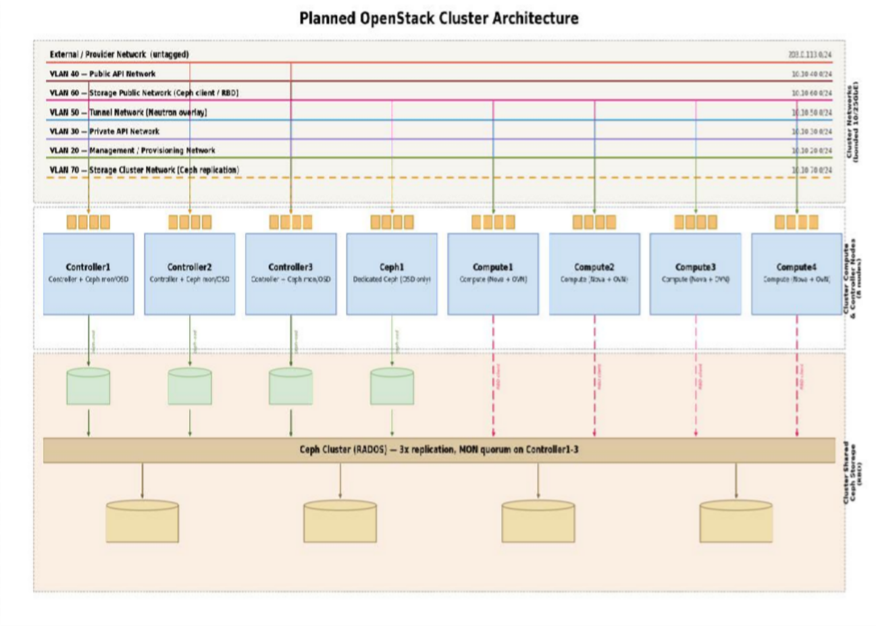

Risk Assessment
Risk Impact Mitigation
Hardware Failure High Multi-controller HA and Ceph replication
Network Failure High Redundant network paths and VLAN separation
Storage Failure High Ceph replication and monitoring
Deployment Failure Medium Validate inventory and run pre-checks
Configuration Errors Medium Peer review and staged deployment
Capacity Exhaustion Medium Regular capacity monitoring and scaling

Constraints
Constraint Description

Hardware Resources Limited to the initial 8-node cluster
Deployment Window Must align with approved maintenance schedule
Network Configuration Requires coordination with the network team
Storage Capacity Limited by available disks until expansion
Budget Must remain within the approved infrastructure budget

